Nez Perce Tribe / Nez Perce National Forest
Road Decommissioning Partnership 2005

The Nez Perce Tribe and Nez Perce National Forest monitor road decommissioning projects in order to track the effectiveness of an aggressive road decommissioning program on the forest. Monitoring protocols are designed to answer questions pertinent to decommissioning goals and provide feedback to the decommissioning program on treatment effectiveness. Treatments monitored include: general prism treatments (recontour, outslope, decompaction, or abandonment), stream channel treatments, cross drain channels, and seeded and planted vegetation.

From August 2003 to August 2004, 20 miles of road were decommissioned within Meadow Creek of the South Fork River on the Nez Perce National Forest under a Participating Agreement between the Nez Perce Tribe and the Nez Perce National Forest. Four monitoring segments were set up on three roads that were decommissioned. These four segments are intended to be a representative sample across the 20 miles of decommissioned roads.

Monitoring Action

Field methods include both qualitative assessments and quantitative measurements on selected segments of decommissioned roads (Table 1). Approximately one monitoring segment is set up for at least every 10 miles of road decommissioned. These segments are established in the year they were decommissioned (year 0). Data is collected along the segments in the first year after decommissioning (year 1), the second year after decommissioning (year 2), and fifth year after decommissioning (year 5). The intent is to revisit there sites in the tenth year (year 10) after decommissioning.

Table 1. Monitoring sites visited in 2005

DATE MONITORED | YEAR OF DECOMMISSIONIG | MONITORING YEAR | DRAINAGE | ROAD | SEGMENT #
Oct-05 | 2003 | 2 | Meadow Cr | 244F | 1
Oct-05 | 2003 | 2 | Meadow Cr | 1851C | 1
Oct-05 | 2004 | 2 | Meadow Cr | 1852E | 1
Oct-05 | 2004 | 2 | Meadow Cr | 1852E | 2

There are four main areas in which we focus our monitoring; Surface Erosion, Revegetation, Stream Grade Channels (SGC), and Cross Drain Channels (CDC). Along with the four areas of focus, are questions that we try to answer associated with each one.

- Surface Erosion: How much surface erosion was observed on the decommissioned road segments? Define the feature or treatment associated with the recorded erosion.

Findings:

• All segments monitored exhibited at least one instance of surface
erosion. At two of the sites some of the new erosion is attributed to
wildlife/cattle forming a trail at the top of the SGC.

• The surface erosion observed was either associated with a SGC or CDC.

▫ Road 1851C exhibited erosion over 5% of the SGC, but no new erosion
since last year other than that associated with a wildlife trail.

▫ Road 1852 E #1 has eroded approximately 15% on side wall of SGC
due to steepness of channel sides.

▫ Road 1852E #2 has eroded approximately 10% at the bottom 1/3 of the
channel on the right bank most likely due to lack of structure in the
stream combined with high flows.

▫ The surface erosion at road 244F is associated with a CDC.

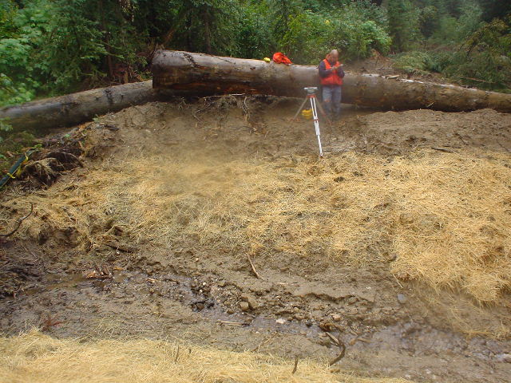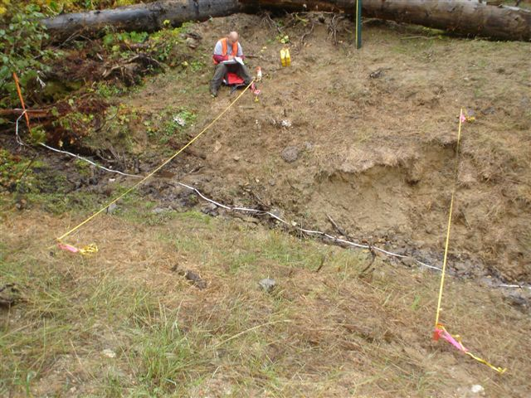
Figure 1. Road 1851C, comparison of 2004 2005 photos for surface erosion.

2. Revegetation: Is there sufficient ground cover to control surface erosion? Is
there succession of native plants species?

Findings:

• As anticipated, we have noticed a significant increase in the amount of
vegetation (grass) growing at our monitoring sites compared to the year 1data. The area of concern that we found in our monitoring is the large increase in the amount of weeds (Bull and Scotch thistle).

• Vegetation on the banks of the SGC is growing back at a much slower rate than
the rest of the decommissioned area due to to much straw being laid down.

• Road 244F had a 7.6% increase in the amount of weeds from 2004 to 2005
and road 1851C had an 8.4% increase of weeds in the same time period.

Figure 2. Ground cover type on decommissioned road 1851C.

On this segment we see a very nice increase in the amount of vegetation that is
expected in year two after decommissioning.

Figure 3. Breakdown of vegetative cover on road 1851C.

Figure 4. Ground cover type on decommissioned road 244F monitoring segment.

Figure 5. Breakdown of vegetative cover on rd 244F.

The increase in forbes is the progression that we are looking for but an area of concern is in the nearly tripling of the amount of weeds (thistle) in this monitoring area.

3. Stream Grade Channel: How much does each channel adjust
(degrade/aggraded) over time? Is the size of the bed material increasing
(indicating degradation) or decreasing (indicating aggradations) over time?

Findings:

• We have observed that putting a lot of straw in and on the side slopes of the
SCG is slowing the process of the channel forming and the rate at which
vegetation is coming back.

• The vertical changes in the SGC’s is minimal, but we are seeing change
in the channel adjusting from side to side which is decreasing the velocity of
the water and minimizing some of the erosion associated with water flow.

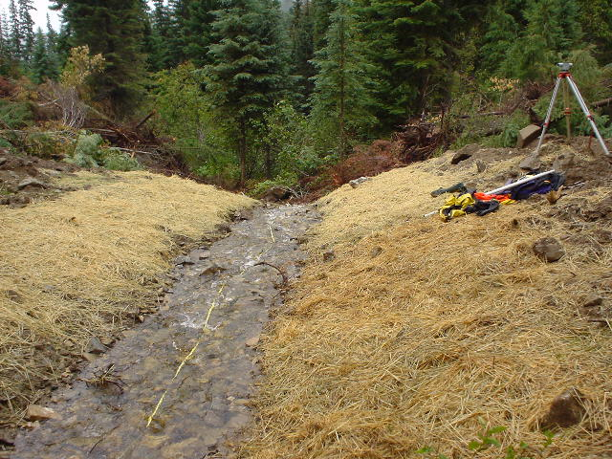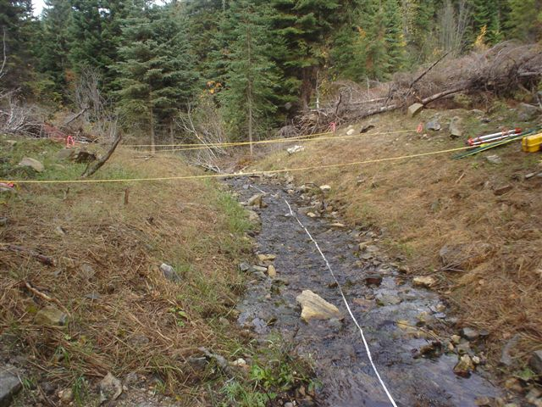
Figure 6. SGC on rd 1852E; picture on left-2004, picture on right-2005

Figure 7. Longitudinal Profile rd 1852E #2.

There was some slight aggradation from 2004 to 2005 partly due to some streambank erosion near the bottom 1/3rd of the SGC.

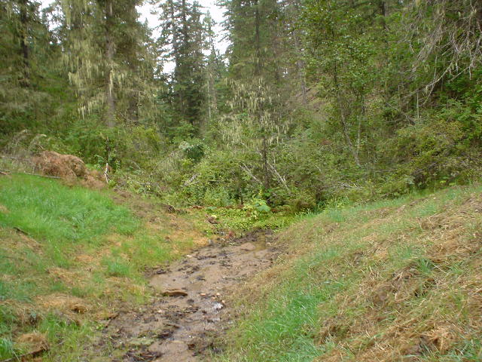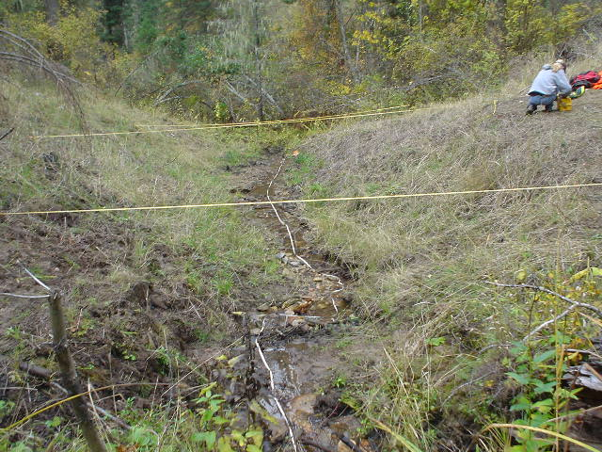
Figure 8. SGC road 244F; picture on left-2004, picture on right-2005.

4. Cross Drain Channel: Are the cross drain channels associated with surface water drainage or converted (intercepted) groundwater? Do the cross drain channels function to restore natural surface and subsurface drainage patterns? How well are they mimicking natural function while minimizing risk?

Findings:

• The CDC on rd 244F exhibits undercutting at the top of the cutbank and is
pooling water within the CDC due to lack of slope.

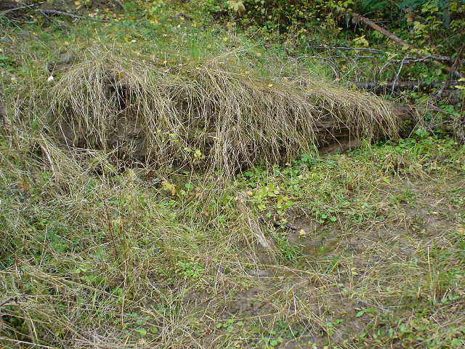
Figure 9. Cutbank erosion and pooling water at CDC on rd 244F.

Recommendations:
• Place less straw in and on side slopes of SGC to promote faster revegetation of forbes.
• Harvest local willows for sprigging on SGC to provide bank stabilization and shade.
• Place some structure (rock or wood) in SGC to slow velocity of water.
• Look into possibilities for post treatment for problem weed areas.

